CENTRELINE TEA BROKERS LIMITED MOMBASA

# THE KENYA CROP AND WEATHER WEEK UPTO 16TH SEPTEMBER 2025

# EAST OF RIFT

# KIAMBU/MURANGA/NYERI/MERU/KIRINYAGA

Rainfall was recorded over few parts of this region.

Light rains were experienced in the morning, giving way to sunny intervals. Afternoon and night showers occurred over a few places.

Daytime (maximum) temperatures increased while night-time (minimum) temperatures decreased over most stations.



Crop harvest increased.

# WEST OF RIFT

# NANDI/KERICHO/BOMET/KAKAMEGA/KISII

Most parts of the Highlands West of the Rift valley and Lake Victoria Basin received rainfall.

Morning sunny intervals with occasional rains occurred over a few places. Afternoon showers and thunderstorms experienced over a few to several places. Few places received night showers

Daytime (maximum) temperatures increased while night-time (minimum) temperatures decreased over most stations

Crop harvest at previous week’s level.

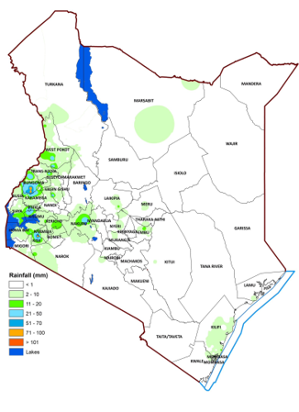

**16TH SEPTEMBER 2025**